|  |  |
| --- | --- |
| Course Number | ELE532 |
| Course Title | Signals and Systems I |
| Semester/Year | F2022 |
| Instructor | Dimitri Androutsos |
| TA Name | Sarina Taki |
| Section No. | 08 |
| Submission Date | 02-October-2022 |
| Due Date | 03-October-2022 |

|  |  |  |
| --- | --- | --- |
| Student Name | Student ID | Signature* |
| Ahmad El-Gohary | 501011852 |  |

*By signing above, you attest that you have contributed to this submission and confirm that all work you have contributed to this submission is your own work. Any suspicion of copying or plagiarism in this work will result in an investigation of Academic Misconduct and may result in a “0” on the work, an “F” in the course, or possibly more severe penalties, as well as a Disciplinary Notice on your academic record under the Student Code of Academic Conduct, which can be found online at:

http://www.ryerson.ca/content/dam/senate/policies/pol60.pdf

Contents

Introduction 3

Lab Results 3

Conclusion 22

# Introduction

The objective of this lab is to use Matlab functions to manipulate signals by time shifting, scaling and/or reversing.

# Lab Results

1.46:

1.47:

A1-1.46

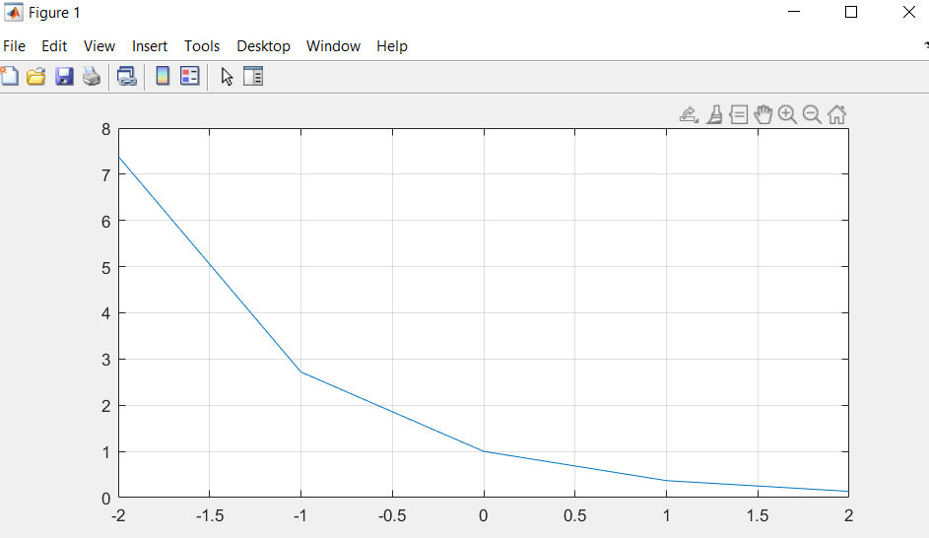

A2

The graphs are very similar, in fact they are identical, as cos(2*pi*t) is one for all integer values in the range t = [-2:2] meaning at these points the graph at A1-1.46 is f(t) = e-t *(1) which is the same function for A2 f(t) = e-t thus both functions resulted in the same graph for integer values in the range t = [-2:2].

Both graphs were manipulated by the same factors (expanded by a factor of 2 on x axis and shifted by a ½ and ¼ to the right respectively) however n2 was expanded then shifted while n4 was shifted then expanded. This resulted in same overall transformations, where both resultant graphs are the same.



Using a loop:



S1 [0 : 0:01 : 4]

S3 [0 : 0:01 : 4]



S5 [0 : 0:01 : 4]

S7 [0 : 0:01 : 4]

4x 401 = 1604

1. A( : ) returns all the values in the matrix in order
2. A([ 2 4 7 ]) returns the values at position 2 4 7
3. [ A >= 0.2 ] returns a 5 x 4 matrix with 1 (true) in each cell that has a value greater than or equal to 0.2 and 0 (false) in each cell that doesn’t
4. A([ A >= 0.2 ]) returns the number in the matrix with values greater than or equal to 0.2 in order
5. A([ A >= 0.2 ])=0 returns matrix A but with all values greater than or equal to 0.2 set to 0

Order in a matrix:

|  |  |  |  |
| --- | --- | --- | --- |
| 1st | 6th | 11th | 16th |
| 2nd | 7th | 12th | 17th |
| 3rd | 8th | 13th | 18th |
| 4th | 9th | 14th | 19th |
| 5th | 10th | 15th | 20th |

Outcome:

a)

b)



c)

The single line command was 426.7% faster than the nested loop.

# Conclusion

At the end of the lab, Matlab functions where more familiar to work with, however I did not know how to save my commands in a file, but I had taken screenshots for them. The content of the lab was similar to the homework questions and the material taught in class, making the lab questions easy to understand and follow.